Q1#include<iostream>

#include<conio.h>

#include<stdio.h>

using namespace std;

class student

{

private:

int admno;

char sname[20];

float eng,math,science;

float total;

float ctotal()

{

return eng+math+science;

}

public:

void Takedata()

{

cout<<"Enter admission number ";

cin>> admno;

cout<<"Enter student name " ;

cin>>(sname);

cout<< "Enter marks in english, math, science ";

cin>>eng>>math>>science;

total=ctotal();

}

void Showdata()

{

cout<<"Admission number "<<admno<<"\nStudent name "<<sname<<"\nEnglish "

<<eng<<"\nMath "<<math<<"\nScience "<<science<<"\nTotal "<<total;

}

};

int main ()

{

student obj ;

obj.Takedata();

obj.Showdata();

getch();

return 0;

}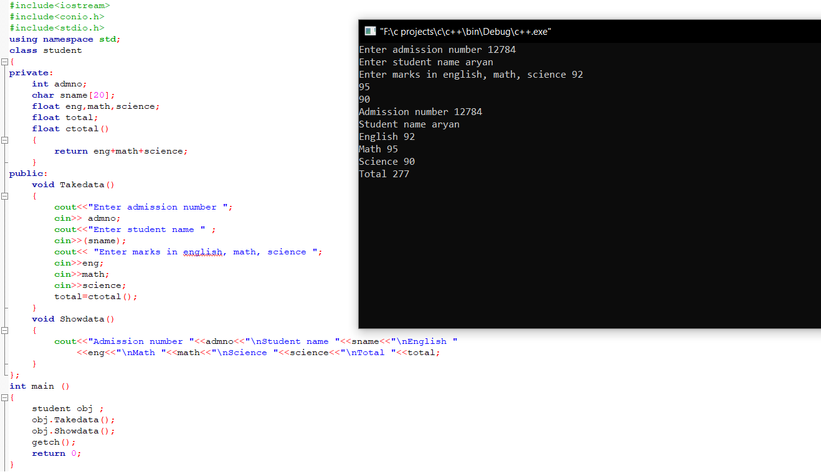

Q2#include<iostream>

#include<conio.h>

#include<stdio.h>

using namespace std;

class batsman

{

int bcode;

char bname[20];

int innings,notout,runs;

int batavg;

void calcavg()

{

batavg=runs/(innings-notout);

}

public :

void readdata ();

void displaydata();

};

void batsman::readdata ()

{

cout<<"Enter batsman code ";

cin>> bcode;

cout<<"Enter batsman name ";

cin>>(bname);

cout<<"enter innings,notout and runs ";

cin>>innings>>notout>>runs;

calcavg();

}

void batsman::displaydata()

{

cout<<"Batsman code "<<bcode<<"\nBatsman name "<<bname<<"\nInnings "<<innings

<<"\nNot out "<<notout<<"\nRuns "<<runs<<"\nBatting Average "<<batavg;

}

int main()

{

batsman obj;

obj.readdata();

obj.displaydata();

getch();

return 0;

}

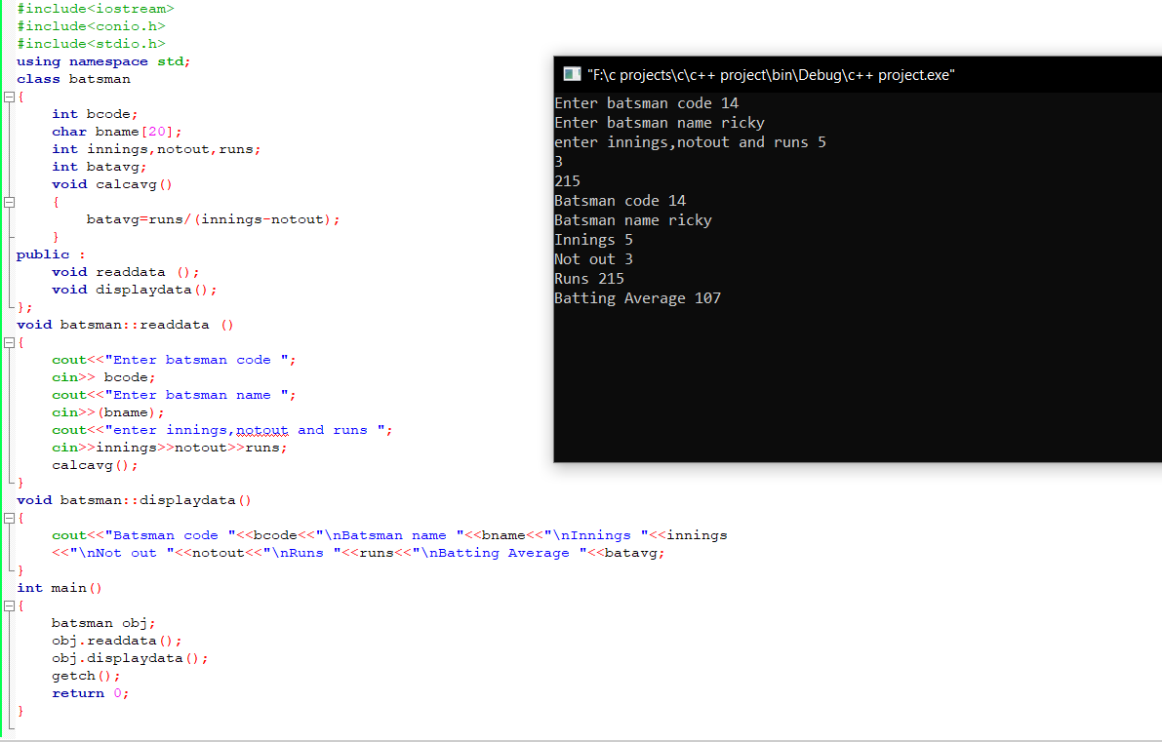

Q3

#include<iostream>

#include<conio.h>

#include<stdio.h>

using namespace std;

class TEST

{

private:

int TestCode;

char Description[30];

int NoCandidate;

int CenterReqd;

int CALCNTR()

{

return (NoCandidate/100)+1;

}

public:

void SCHDULE();

void DISPTEST();

};

void TEST::SCHDULE()

{

cout<<"Enter Test code ";

cin>> TestCode;

cout<<"Enter description ";

cin>>(Description);

cout<< "Enter no of candidates ";

cin>>NoCandidate;

CenterReqd=CALCNTR();

}

void TEST :: DISPTEST()

{

cout<<"Test code "<<TestCode<<"\nDescripton "<<Description<<"\nNo of candidate "

<<NoCandidate<<"\nCenter required "<<CenterReqd;

}

int main ()

{

TEST obj;

obj.SCHDULE();

obj.DISPTEST();

getch();

return 0;

}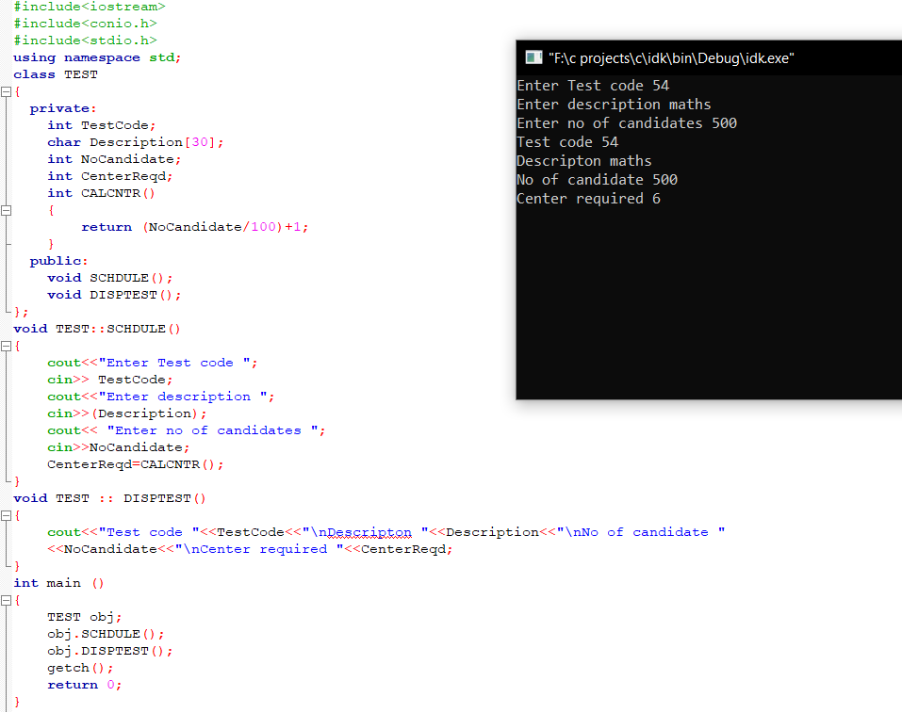

Q4

#include <iostream>

using namespace std;

class flight

{

private:

int flightnumber;

char destination[30];

float distance;

float fuel;

float calfuel()

{

if(distance<=1000)

{ fuel = 500;

}

else if(distance>1000 &&distance<=2000)

{

fuel = 1100;

}

else if(distance>2000)

{

fuel = 2200;

}

return fuel;

}

public:

void feedinfo()

{

cout<<"Enter Flight number:";

cin>>flightnumber;

cout<<"Destination:";

cin>>destination;

cout<<"distance :";

cin>>distance;

calfuel();

}

void showinfo()

{

cout<<"Flight number:"<<flightnumber<<endl;

cout<<"destination"<<destination<<endl;

cout<<"Distance : "<<distance<<endl;

cout<<"Fuel :"<<calfuel()<<endl;

}

};

int main()

{

flight obj; //object creation

obj.feedinfo();

obj.showinfo();

return 0;

}

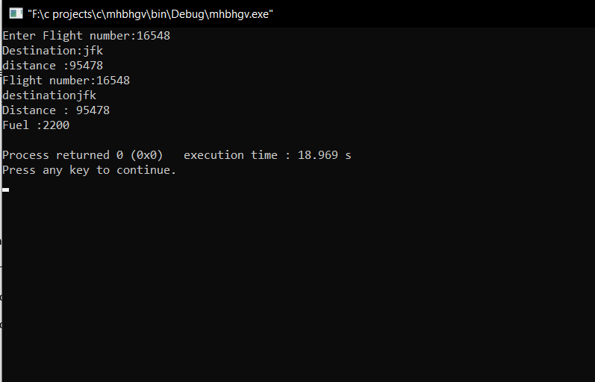

Q5#include<iostream>

#include<stdio.h>

#include<conio.h>

using namespace std;

class BOOK

{

int BOOKNO;

char BOOKTITLE[20];

float PRICE;

void TOTAL_COST(int N)

{

float tcost;

tcost=PRICE*N;

cout<<tcost;

}

public:

void INPUT()

{

cout<<"Enter Book Number ";

cin>>BOOKNO;

cout<<"Enter Book Title ";

cin>>(BOOKTITLE);

cout<<"Enter price per copy ";

cin>>PRICE;

}

void PURCHASE()

{

int n;

cout<<"Enter number of copies to purchase ";

cin>>n;

cout<<"Total cost is ";

TOTAL_COST(n);

}

};

int main()

{

BOOK obj;

obj.INPUT();

obj.PURCHASE();

getch();

return 0;

}

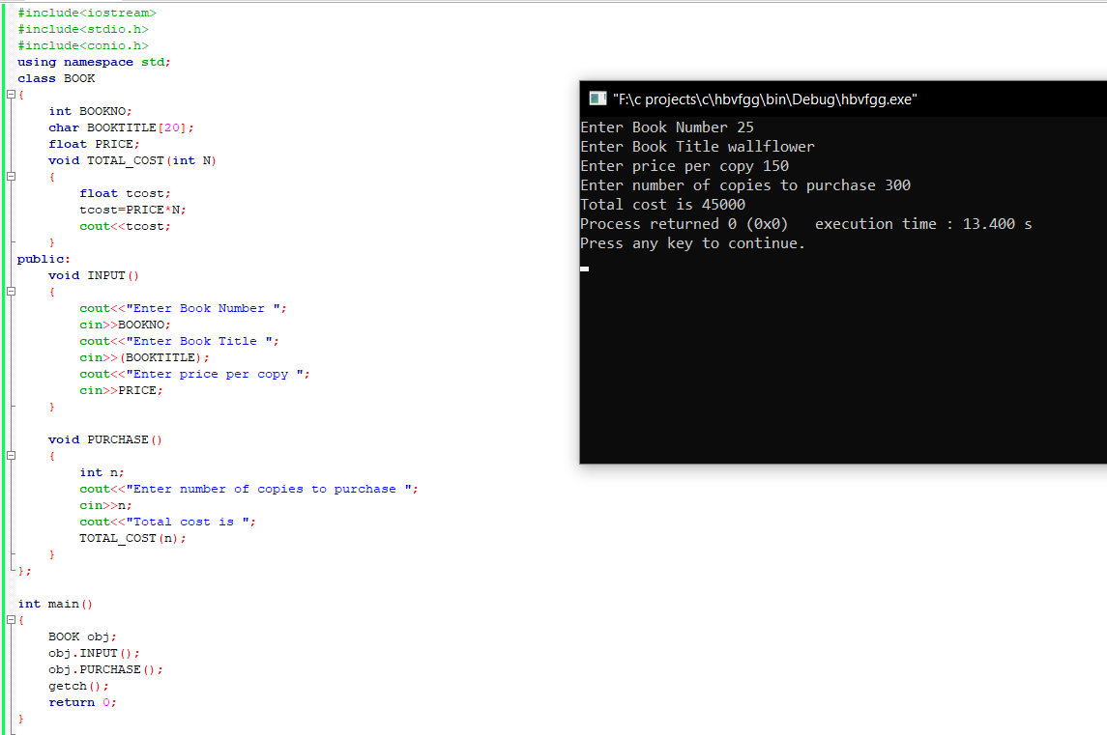

Q6#include<iostream>

#include<stdio.h>

#include<conio.h>

using namespace std;

class REPORT

{

int adno;

char name[20];

float marks[5];

float average;

void GETAVG()

{

average = (marks[0]+marks[1]+marks[2]+marks[3]+marks[4])/5;

}

public:

void READINFO();

void DISPLAYINFO();

};

void REPORT::READINFO()

{

do

{

cout<<"Enter 4 digit admission number ";

cin>>adno;

}while(adno<999 || adno>10000);

cout<<"Enter name";

cin>>(name);

cout<<"Enter marks in ";

for(int i=0;i<5;i++)

{

cout<<"Subject "<<i+1<<":";

cin>>marks[i];

};

GETAVG();

}

void REPORT::DISPLAYINFO()

{

cout<<"Admission number:"<<adno<<" Name:"<<name<<" Marks are:"<< marks[0]<<" "<< marks[1]

<<" "<<marks[2]<<" "<< marks[3]<<" "<< marks[4]<<" Average:"<<average;

}

int main()

{

REPORT obj;

obj.READINFO();

obj.DISPLAYINFO();

getch();

return 0;

}

